
Castle Hill News: 06.12.24

Dear Parents/Carers,
There has been much to celebrate here at Castle Hill this week. From sport to raising money for charity, the children of Castle Hill continue to shine. We have a busy two weeks left of this term so please check out the dates section at the bottom of this newsletter.
Christmas Postbox
I am delighted to announce the return of our Christmas postbox made by one of our governors Mr. Chris Lines.
From Monday, children will be able to bring their Christmas cards to school and pop them in the postbox in the hall. The envelopes need to have the name and the class of the person they are intended for. The postbox will be emptied daily and cards will be given out at the end of the day for the children to take home.
KS1 football report from Mr. Bowers
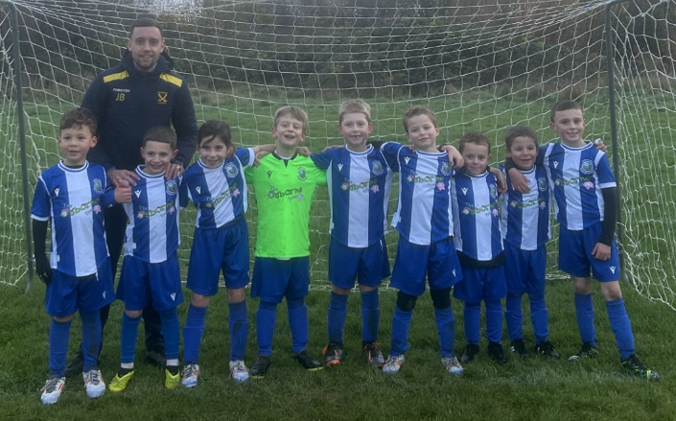

Our Year Two football team played their first competitive match on Sunday vs Highnam YFC. Castle Hill started brightly and took the lead early on in a game but soon found themselves 1-5 down. However, the team showed excellent resilience and determination to equalise in the last minute of the game! The excitement was not over for the team, and the parents, as Freddie Bowers scored the winning goal with ten seconds to go. Cue the celebrations!

Final Score Highnam YFC 5-6 Castle Hill [Freddie x4 Zakari x2] Players of the Match: Nina and Henry Price.

On Tuesday evening, it was time for match number two. The children travelled to Matson to face Robinswood Primary. The teamwork again was fantastic to see and there were some great goals scored. All of the children played with a smile on their face and represented the school extremely well. Thank you to all the parents that supported the team.

Final Score Robinswood 0-4 Castle Hill [Nina, Harper x2 and Henry Price] Players of the Match: Tommy and Harper.

Congratulations to you all and thank you to Mr. Bowers.
KS2 ‘A’ team
On Thursday evening, the KS2 ‘A’ team played a very close match against The Croft School in Painswick. The score was at 3-3 when the opposition scored just before the whistle. Well played to you all especially in those horrible weather conditions.
Thank you to Mr. Enon and Mrs. Gibbs for their support and for the parents who stood on the sidelines in that torrential rain to cheer their children on!
KS1 gymnastics
On Wednesday, 6 of our most talented KS1 gymnasts attended a gymnastics competition at St. Peter’s High School. Well done to Edhveera, Amelia, Cameela, Rylee, Elsie and Ivy. They all did incredibly well as the competition was extremely tough. Congratulations to you all for your excellent performances and to Rylee, Cameela and Edhveera for securing medals.
Thank you to Mr. Enon and Mrs. Gibbs for accompanying them and for calming their nerves.

Trussell Trust Christmas Shoeboxes
Wow! Thanks to so many generous donations, we have filled 53 shoeboxes to send to children in less fortunate countries. We are always overwhelmed with your generosity, with so many families providing filled boxes too! Well done Castle Hill!
Thank you to Miss Baldwin for organising.
Children in Need
The final total raised for Children in Need was a fantastic £280.59. Thank you so much for your generosity.

Big Write The Snowman:
What is happening in this picture?
What can you see?
Have you ever read this book or seen this film?
Have you ever built a snowman?
If you could fly around the world with a snowman, what would you see?
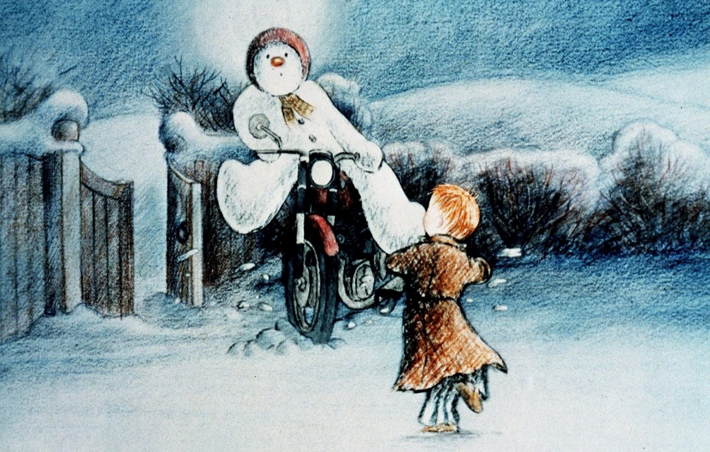

Polite reminder – School Meal/Breakfast club payments
Please find below a message from our School Business Manager regarding payment for school meals and breakfast club:

As you will already know, school budgets are very tight. Our school meal debt policy (a copy of which can be found on our school website) clearly states:

As from 1st January 2018 Castle Hill Primary School adopted a strict NO DEBT policy relating to the School Meal and Breakfast Club service. If debts are incurred, then the school budget has to pay for them. This means that money which should be spent on the children’s education is used to pay for debts incurred by parents. Every parent will agree that this is unacceptable and we request that all parents give this policy their full support.

I thank all parents that are paying regularly but we are increasingly having to spend time sending out reminder letters and emails to parents who have incurred debt on their child’s Parentpay account relating to school dinners or breakfast club. As a school, this is not a position that we can sustain and as such, would remind all parents that dinner money and breakfast club accounts on Parentpay should be either kept in credit or at a zero balance at all times.

Going into the New Year, please can you ensure that the Parentpay accounts are clear of any historic debt and ensure that they are always kept topped up where your child is partaking in optional school dinners or the breakfast club offering.
If you are struggling with genuine financial hardship, please do not hesitate to contact me and we can look at whether you qualify to apply for free school meals.

Sincere thanks in advance. Jo Mabbutt – School Business Manager

Key dates for next week
Monday 9th December – 9.30am Launch of new online provision map for SEND pupils – invitation only
Wednesday 11th December - My Plan+ appointments – invitation only
Thursday 12th December – EHCP appointments – invitation only
Friday 13th December 9am – Reception nativity play. This is one of our favourite times of the year. Please come along to watch the magic of your child performing in their first ever school play.
Friday 13th December – Y5/Y6 trip to Cadbury World – school uniform
Friday 13th December – whole school. Christmas jumper day.
Friday 13th December – Y1-Y6. PAWS due in.

Key upcoming dates
Tuesday 17th December – Christmas dinner and party day (details to follow).
Thursday 19th December – Y5/Y6 ONLY – Christmas jumper day in lieu of Friday 13th December.
Thursday 19th December – term finishes at 2pm.
PLEASE JOIN US FOR SOME CAROLS AND MINCE PIES ON THE KS2 PLAYGROUND FROM 2PM
Amazon Wishlist links
English https://amzn.eu/bnNWVET Forest School https://amzn.eu/fkxiP5O

Have a wonderful weekend.
Mrs. Ettrick

