
Castle Hill News:28.2.25

Dear Parents,
Welcome back! It has been delightful to see the children back in school this week. Let’s hope that this half term brings with it a bit more sunshine.
World Book Day
It is almost that time of year again! Next Thursday (6th March) is World Book Day.
As in previous years, we will not be asking the children to dress up in costume. This ensures the focus remains on books and reading which is the true purpose of the day. It also means that parents hopefully won’t feel the pressure to buy or create a costume. All children are invited to bring in their favourite book to share in class. They will also be bringing home the famous World Book Day token! The teachers will be swapping over at storytime to read a story to a different class and we are going to have our very own Masked Reader assembly!
The Great Book Give Away
As part of World Book Day, we would like to hold a book ‘give away’. We have many books from our previous reading scheme Bug Club that are as good as new and a great way to support with extra reading at home.
At the end of the day on World Book Day, we will be putting out tables of books for your children to take home. If you would like to make a donation, then you are very welcome to do so, but you are very welcome to take the books for free. We would ask that you do not take more than 2 books for your child to ensure that everyone has a fair chance.
Girls’ Football
On Thursday after school, Castle Hill hosted Shurdington in a thrilling local derby!! It was a very exciting match with lots of parents and staff cheering from the sidelines. The team played absolutely brilliantly. We lost 2-0 but were extremely unlucky not to get a goal. The girls created so many opportunities and were close to scoring on many different occasions. Well done to Taylor, Lila, Faith, Isla, Freya, Georgia, Teghan, Kacie, I was so proud of every single one of them. I would like to give a special mention to Teghan for offering to go in goal having never done so before and for making some spectacular saves.
Art Exhibition – 5th March
Just a reminder to bring in your sculptures ready for our Art exhibition next week. I have seen some incredible pieces of work coming into school this week. You are warmly invited to come into the school hall from 3.25, once all pupils have been released, to look at our amazing display of sculptures. You will be able to enter the school via the KS2 library door.
Breakfast Club – Booking: Important information
The system for booking breakfast club will soon be changing. We will let you know when the new system goes live, but wanted to give you advance warning.
To book breakfast club under the new system, you will need to book online and pay in advance for breakfast cub. Breakfast club is becoming increasingly popular and we need to ensure that we have enough staff to cover the session as well as enough food for the children.
Headlice
We have had several cases of headlice in school recently, both in KS1 and KS2, so please be advised that you might need to check your child’s hair and treat if necessary. Many thanks for your vigilance.
School dinner increases
From 1st April 2025, there will be a small increase in the price of a hot school dinner. A hot school dinner will now cost £2.85.
FRIENDS Quiz night
The FRIENDS of Castle Hill are excited to announce their quiz night on Friday 7th March. Please see attached poster for details. We would be delighted if you could come along and support us.
Big Write
This week’s Big Write title is based on an animation.
Taking Flight. Literacy Shed animation https://www.literacyshed.com/takingflight.html


I would like to share with you Ethan’s (Y3) Big Write from last week as Mrs. Richards was so impressed by it.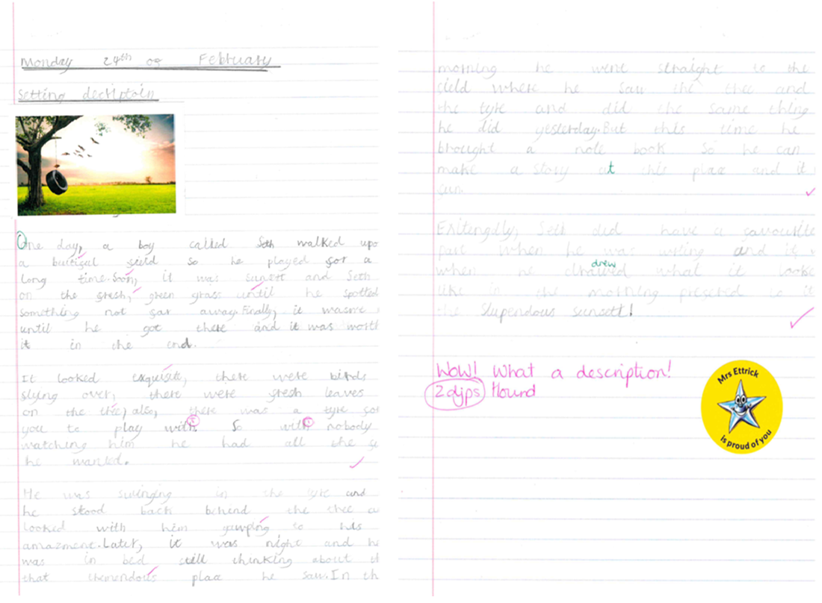

Key dates for next week
Wednesday 5th March – whole school – Art Sculpture exhibition in the hall; 3.15pm
Thursday 6th March – World Book Day
Thursday 6th March – Themed Day lunch:
Menu: A) Vegetable sausage roll
B) Chicken meatball and spaghetti
Chocolate cake and sauce
Friday 7th March – FRIENDS Quiz night 7pm – adults only (see poster)

Key upcoming dates
Tuesday 11th March – Friday 14th March – Y6 – Residential to Viney Hill
Monday 17th March – Y5 Parents – meeting about Y6 residential 2026
Tuesday 25th March – Y5 – trip to Skillzone
Amazon Wishlist links
English https://amzn.eu/bnNWVET Forest School https://amzn.eu/fkxiP5O

Have a wonderful weekend - Mrs. Ettrick

