
Castle Hill News: 23.05.25

Dear Parents,
This half-term has been such a short one, but such a busy one with Ofsted, SATS, new Reception parents’ meeting, Y4 swimming lessons, the swimming gala and more! We have been so lucky with the weather this half-term and hopefully we will see some continued dry weather next week.
3 Peaks Brockworth
Thank you so much to all those in our community who joined us for the 3 Peaks challenge. It was lovely to see so many families, old and new, out and about enjoying walking in our local area. A huge thanks to the FRIENDS of Castle Hill for organising this – I saw first-hand how much work went on behind the scenes. Thank you also to anyone who helped out at the event, from Oscar and Will’s nanna on the BBQ to anyone who helped with registration or marshalled, or helped us in anyway at all. Your support is very much appreciated.
Governors
Our governors work very hard to support our school and, unfortunately, 2 of our governors will be stepping down from office at the end of this academic year. So, we will be sad to say goodbye to Mrs. Shirley Allen, who has worked tirelessly as a governor at our school for many years including holding the positions of both chair and vice-chair of the governing board, and to Mrs. Claire Rigby, nanna of Alfred and Louis, who has also given years of service to our governing body. Together with another governor, Mr. Chris Lines, they have bought this beautiful quote for our children to inspire them all:
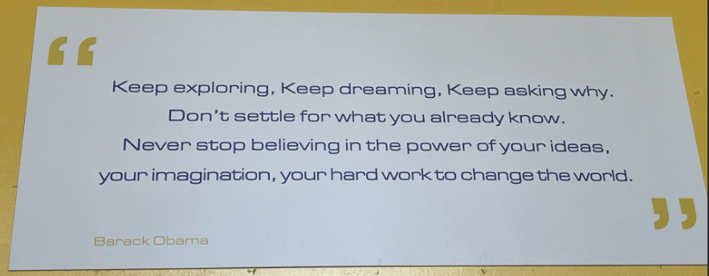

Swimming Gala
This week, some of our pupils attended a swimming gala at GL1. They did amazingly well and we are proud of them all. Please see the attachment with the newsletter for photos and more information.
Big Write
There will be no Big Write title for the first week back as children will be undertaking their end of term writing assessments which will help inform their end of year reports.
Year 6 Bikeability
Year 6 bikeability training will begin on Monday 2nd June. All Y6 pupils should have come home today with a consent form that needs to be signed and brought back to school on the FIRST day back after half-term (Monday 2nd June) in order for them to participate. The letter includes information about bike checks that need to be undertaken before the first session, so hopefully half- term will be a good opportunity to do this. Your child will be expected to wear a bike helmet.
Sports Day: Tuesday 17th June
Weather permitting, we would like to invite you to join your children for a picnic on Sports Day prior to the start of the races. As last year, children will be able to picnic with their families at lunchtime before the races.
Polite reminder:
There are still people parking on the yellow lines. Please remember they are there for the safety of all our children and should not be ignored.
Have a wonderful half-term and we look forward to seeing you all back in school on Monday 2nd June.
Mrs. Ettrick

Key upcoming dates/dates for your diary
Monday 26th May – Friday 30th May – Half term
Monday 2nd June – Back to school; Y6 bikeability begins: PLEASE RETURN CONSENT FORMS
Tuesday 10th June – Y1/2 trip to Berkeley Castle
Tuesday 17th June – Sports Day (Picnic on the field: 12-1pm; Races begin at approximately 1.15pm)
Wednesday 25th June – Reception trip to Cotswold Wildlife Park
Thursday 3rd July – Y1 multi-skills event
Thursday 3rd July – Y5 camping
Friday 4th July – PAWS in
Friday 4th July – Castle Hill Fest – 3pm onwards – ALL welcome
Friday 11th July – Y3/4 trip to Gloucester Museum
Wednesday 16th July – Y6 leavers’ party 3.15 – 5.00 pm (Y6 pupils and staff only)
Thursday 17th July – Y6 leavers’ assembly – 9am start (Y6 parents please come via the main entrance)
Friday 18th July – TERM ENDS – 2pm

